**Monitoring and Safeguarding Employee Wellbeing through Advanced Analytics**

**An Engineering Project in Community Service**

**Phase – II Report *Submitted by***

**1. 21BCE10249 - Tanishka Mishra**

**2. 21BCE10294 - Paras Verma**

**3. 21BCE10413 - Hardik Kankane**

**4. 21BCE11583 - Akash Parmar**

**5. 21BCE10537 - Anondita Dutta**

**6. 21BCE10650 - Apoorva Gupta**

**7. 21BCG10161 - Shrey Borana**

**8. 21BSA10123 - Nikita Raut**

***in partial fulfilment of the requirements for the degree of***

***Bachelor of Engineering and Technology***



**VIT Bhopal University**

**Bhopal**

**Madhya Pradesh**

**9th May, 2024**



**BONAFIDE CERTIFICATE**

Certified that this project report titled **“Monitoring and Safeguarding Employee Wellbeing through Advanced Analytics”** is the bonafide work of – (21BCE10249) Tanishka Mishra, (21BCE10294) Paras Verma, (21BCE10413) Hardik Kankane, (21BCE11583) Akash Parmar, (21BCE10537) Anondita Dutta, (21BCE10650) Apoorva Gupta, (21BCG10161) Shrey Borana,(21BSA10123) Nikita Raut” who carried out the project work under my supervision.

This project report (Phase II) is submitted for the Project Viva-Voce examination held on 7th March,2024

**Supervisor**

**Comments & Signature (Reviewer 1)**

**Comments & Signature (Reviewer 2)**



**DECLARATION OF ORIGINALITY**

We, hereby declare that this report entitled **“Monitoring and Safeguarding Employee Wellbeing through Advanced Analytics”** represents our original work carried out for the EPICS project as a student of VIT Bhopal University and, to the best of our knowledge, it contains no material previously published or written by another person, nor any material presented for the award of any other degree or diploma of VIT Bhopal University or any other institution. Works of other authors cited in this report have been duly acknowledged under the section ''References''.

|  |  |  |
| --- | --- | --- |
|  | Date  9th MAY 2024 | Reg No & Name  (21BCE10249) Tanishka Mishra (21BCE10294) Paras Verma (21BCE10413) Hardik Kankane (21BCE11583) Akash Parmar (21BCE10537) Anondita Dutta (21BCE10650) Apoorva Gupta (21BCG10161) Shrey Borana (21BSA10123) Nikita Raut |

**ACKNOWLEDGMENT**

# This work has benefited in various ways several people. Whilst it would be simple to name them all, it would not be easy to thank them enough. We would like to express our profound gratitude to Vellore Institute of Technology, Bhopal for providing us the opportunity for the completion of our project titled “Monitoring and Safeguarding Employee Wellbeing through Advanced Analytics”.

# We are especially grateful to our supervisor, Dr. M. Manimaran, for his invaluable time and efforts throughout the year. His insightful advice and suggestions were instrumental to the project's success, and we are deeply appreciative of his guidance.

# We also wish to thank our reviewers, Dr. M. Manimaran , Ankush D Tharkar and Dr. Prashant Kumar Pandey , for their helpful feedback and constructive critiques, which significantly improved the quality of our work.

**ABSTRACT**

In today’s fast-paced global business environment, aligning the needs of employees is critical to the success of any organization. The aim of this project is to address the problem of employee burnout by using comprehensive research to identify and defend employee nice-building. Learn the benefits of state-of-the-art technology and artificial intelligence for solutions that no longer inflexibly save you heat and yet also refine and enhance the area of ​​efficiency. Important insights into the factors that contribute to burnout are also furnished through those solutions.

We are passionate about understanding that heat negatively affects every person and business, primarily through decreased productivity, increased medical costs and increased workforce. Our goal is to build predictive models that can detect heat early and use AI and ML to take action to save you.

Our most ambitious dreams mean collecting and reading complete records, growing patterns expected to burn, constantly monitoring employee well-being, if we provide fully customized interventions based on acceptable risks, we will always adjust our strategies for better results. Ultimately, we need to increase both organizational effectiveness and employee happiness through modelling and continuous improvement.

Our method includes more than one steps: facts training, neural network version construction and schooling, and performance assessment. Our studies indicates how AI and ML may be used to count on worker burnout fees and inform proactive control strategies.

This initiative is basically our response to how the present day workplace is converting and the way generation and employee nicely-being are intertwined. Our aim is to guide companies in creating a tradition that values worker nicely-being by using making use of superior analytics, so that you can enable them to effectively control their staff over the years.

# INDEX

**INTRODUCTION**…………………………………………………………………………8

1.1 Motivation …..……………………………………………………………………….8

1.8 Objective …………………………………………………………………………….9

1.9 Data Collection and Evaluation ……………………………………………………..10

1.10 Model Construction ………………………………………………………………….10

1.11 Continuous Monitoring ………………………………………….…………………..10

1.12 Personalized Interventions ……………………………………….………………….12

* 1. Evaluation and Revisions……….………………………………… ……….…....11

1.14 Overall Impact and Continuous Improvement ……………………………..……….11

**EXISTING WORK/LITERATURE REVIEW**……………………………………. 12

* 1. Statistics on employee burnout………………………………………………..12
  2. Using Machine Learning to Predict Employee Burnout … …………………....12

2.3 The advantages of proactive intervention ………………………………………......13

2.4 Present Research on Predicting Employee Burnout ……………………..…………14

**TOPIC OF THE WORK**……………………………………………………………….15

3.1 System Design / Architecture ………………………………………………………. 15

3.2 Working Principle ………………………………………………………………...… 16

3.3 Results and Discussion ………………………………………….…………………....16

* 1. Individual Contribution by members ………………………………………………... 18

**4. References** …………………………………………………...………… 21

1. **Appendix**………………………………………..…………………… 25
2. **Biodata** ……………………………………………………………….…………. 30

# 1. INTRODUCTION

In today's workplace, sweat is increasingly common, affecting both organized and unorganized sectors. Burnout, characterized by work-related stress, can negatively affect a person's physical health, mental health, and overall productivity. In the organized sector where workers work in consolidated companies or organizations, the sweat is seen in the long working hours. Some of these include long working hours, high pressure to achieve goals and lack of work-life balance. The competitive nature of this environment, with high expectations and deadlines, increases stress and employee turnover. But in the informal sector, which has a large share of the world's workforce, the heat comes from a variety of sources. Here, workers often face harsh working conditions, including irregular work hours, low wages, and limited access to benefits and support systems. Lack of compliance makes it difficult for individuals to address and reduce the stressors that cause burnout. Despite the differences between these areas, the prevalence of burnout reflects a general problem in modern workplace culture. Recognizing and addressing issues related to burnout is critical to promoting employee well-being across industries and creating an environment that focuses on sustainable results and achievement.

## 1.1 Motivation

Employee burnout is a state of physical, emotional, and mental weariness caused by extended stress and a heavy workload in the office. It frequently leads to lower productivity, disengagement, and bad consequences for mental health.

Employee burnout has a negative impact on individuals and organisations in today's corporate context. Burnout not only reduces productivity and job happiness, but also leads to high staff turnover rates, threatening organisational stability. Additionally, the consequences include increased healthcare expenses, emphasising the importance of taking primitive actions. Recognising people as a company's most valuable asset necessitates understanding and addressing burnout. It is crucial for creating a workplace that promotes both employee well-being and productivity . In summary, anticipating employee burnout rates stems from a desire to increase employee well-being, improve organisational performance, and fulfil legal and ethical obligations to employees. It enables proactive actions to prevent burnout and provide a supportive work environment that promotes employee engagement and productivity.

### The Role of AI and ML

Embracing the transformative capabilities of Artificial Intelligence (AI) and Machine Learning. (ML) unveils a strategic avenue to not only comprehend but actively prevent burnout. Through data-driven analyses, these technologies empower us to discern intricate patterns and emerging trends related to burnout, offering a profound understanding of its root causes.

### 1.1.2 Predictive Models for Early Intervention

The integration of AI and ML facilitates the creation of predictive models capable of discerning early symptoms of burnout. This foresight equips organizations with a proactive approach, enabling targeted interventions to foster a resilient and well-being-centric culture within the workplace.

### 1.1.3 Significance of a Proactive Approach

This project's motivation lies in the recognition that a proactive stance towards employee burnout is not merely advantageous but indispensable in the contemporary professional landscape. By harnessing the analytical prowess of AI and ML, we aim to empower organizations to pre-emptively identify, understand, and mitigate factors contributing to burnout, ultimately fostering a workplace culture that prioritizes health, resilience, and sustained productivity.

## 1.2 Objective

### 1.2.1 Data Collection and Evaluation

The main objective is at enhancing the welfare of personnel and guards in SIS India - Security Agency is to collect relevant data from various critical sources. Our data collection covers performance criteria, health assessments, and all external environmental factors that can affect well-being. Using comprehensive research methods, we intend to delve into the various factors contributing to employee fatigue and burnout. This comprehensive study is designed to reveal important insights that can inform strategies for improving the health and productivity of SIS India security personnel.

### 1.2.2 Model Construction

As part of the objectives of our project, we focus on state-of-the-art AI techniques for predictive modelling. The purpose of this model is to accurately predict and predict the likelihood of separation between staff and guards. One of the most important features of these models is their ability to distinguish between particles and the first sign of a potential fire. Due to the extensive training of this system on real datasets, models can effectively identify subtle factors affecting employee well-being Our goal is to provide a powerful tool that encourages early intervention to preserve employee well-being and on the production of goods.

### 1.2.3 Continuous Monitoring

Our main objective is to develop a reliable framework specifically designed for the ongoing welfare assessment of security personnel. The system is optimized for continuous data collection and processing, allowing for rapid discovery and testing. With the help of actionable data and real-time information, it will enable managers and HR professionals to quickly overcome and solve any new problems related to the performance and well-being of security personnel. The establishment of this system underscores the commitment to protect the welfare and productivity of safety personnel, and underscores the critical role of real-time monitoring in maintaining overall employee health and productivity. This approach not only increases immediate response but also supports long-term efficiency.

### 1.2.4 Personalized Interventions

Central to the project is the development of an individualized intervention framework, meticulously tailored based on identified risk factors. Through data analysis, specific risk factors will be identified, and interventions will be custom-designed to meet the unique needs of each employee. This approach aims to foster a collaborative and responsive working environment, acknowledging the diversity of employee needs and well-being.

### 1.2.5 Evaluation and Revisions

A continuous feedback loop is established for regular evaluations and revisions of both implemented interventions and the model itself. Feedback from employees and changes in organizational structure will be systematically incorporated into the refinement process. This iterative approach ensures the ongoing effectiveness and relevance of the interventions in a dynamic organizational context.

### 1.2.6 Overall Impact and Continuous Improvement

The project, rooted in artificial intelligence and machine learning, is designed for continuous improvement. The system evolves iteratively, adapting to changes in working conditions and organizational dynamics. This comprehensive and detailed approach aims not only to enhance employee resilience and motivation but also to contribute significantly to increased organizational success and overall employee satisfaction.

1. **Existing Work / Literature Review**

This initiative monitors employee well-being and uses sophisticated analytics to forecast staff burnout. The paper grounds its approach and supports its claims with research from other sources. The pertinent literature that was evaluated for this report is broken down as follows:

**2.1 Statistics on employee burnout:**

The have a look at specializes in one supply that exposes the pervasive difficulty of worker burnout, implying that it is able to offer complete statistics on the prevalence of this circumstance inside the place of business. These facts can consist of thorough information at the range of human beings suffering burnout throughout industries and process roles. In addition, the supply is predicted to observe the various results of burnout on character performance, group dynamics, and usual organizational overall performance.

Additionally, the source is predicted to explore the complex dating among employee properly-being and productivity outcomes, losing light on how burnout can lessen motivation, engagement, and process pride inside the administrative centre. It can also cope with the potential lengthy-time period effects of unchecked warming, such as increased absenteeism, waste, and increased healthcare charges for agencies

In addition to obtaining and analysing quantitative records to provide a complete understanding of burnout variables and their effect on human beings and groups, this qualitative proof may be an impartial operator encouraged burnout records and comments from managers and HR specialists

The supply may discuss techniques and measures that may be used to avoid and manipulate warmth stroke correctly. These techniques can consist of everything from organising institutional regulations that assist intellectual health help services and work-life stability to creating a psychologically secure environment and open verbal exchange in the place of job. The source makes a speciality of evidence-based totally techniques and quality practices to equip enterprise owners and stakeholders with the competencies and sources they need to proactively deal with warming and create wholesome sustainable situations plant.

Ultimately, the materials offered can serve as guidelines for fate research and advocacy with the goal of increasing our knowledge of inflammation and developing specific solutions to address it. More rigorous approaches to record collection, longitudinal management, and interdisciplinary collaboration may be needed to explore connections between people, institutions, and social resources that contribute to resilience between these temperatures.

However, politicians and lecturers searching for to reduce the commonplace hassle of burnout in current settings have observed the outcome to be an tremendous product for clinicians. Essentially, this software is us a reaction to the converting nature of the cutting-edge place of work, where era and professionalism move traces. By using complete research, we goal to assist groups broaden a tradition that places well being first, leading to ongoing success in handling their workforce.

**2.2 Using Machine Learning to Predict Employee Burnout**:

The study provides a detailed presentation on how machine learning (ML) techniques can be used to predict employee burnout. These factors likely examine the feasibility and effectiveness of data-driven approaches to identifying early indicators of worker burnout.

For example, research publications or articles that focus on the application of ML algorithms in standard situations such as health care professionals predicting temperatures may affect the citations in the study around allowing a more accurate prediction of the onset of combustion.

Drawing on multiple sources, including academic data and code repositories, it enriches the conversation about temperature forecasting and provides valuable insights for researchers, practitioners, and policymakers

Overall, the paper’s reliance on prior studies helps to bolster its theoretical framework, strengthen its methodology, and establish its relevance in the scholarly panorama by extending the burnout forecast.

Furthermore, research can gain insights from examining the ethical implications and limitations of using ML for temperature forecasting, including data privacy, algorithmic bias, and potential side effects inadvertently resulting in or stigmatizing individuals identified as at risk of burnout Contexts: Quality of personnel issues, ML.

Overall, such additions highlight the growing interest in and investment in using data-driven approaches, including ML, to address employee burnout emphasizes the solution of the difficult issue. Combining findings from various research areas with real-world applications, the study aims to inform organizational leaders, policy makers, and researchers about the potential benefits and considerations of adopting predictive analytics to manage burnout emergency response in the workplace.

**2.3 The advantages of proactive intervention**

The examine underscores the significance of adopting a proactive stance in opposition to team of workers burnout, emphasizing the blessings of early intervention in mitigating its unfavourable results. Within the stated resources, a demonstration of these advantages is anticipated, probably via empirical proof derived from research examining the efficacy of prophylactic techniques towards burnout.

These assets are predicted to offer insights into the tangible benefits associated with early intervention, including however no longer restricted to, discounts in healthcare fees and upgrades in worker nicely-being. By reading information and consequences from numerous interventions, those research elucidate the ability fee savings for groups on account of reduced absenteeism, turnover fees, and healthcare utilization among employees who get hold of well timed assist to prevent or manage burnout.

Furthermore, the indexed sources are possibly to delve into the specific mechanisms thru which proactive techniques contribute to the prevention of burnout and the advertising of ordinary personnel resilience. This may additionally contain exploring the role of organizational subculture, management practices, and employee guide applications in growing a conducive environment that fosters psychological fitness and expert fulfilment.

Moreover, those research may additionally have a look at the lengthy-term impact of early intervention on organizational performance metrics, inclusive of productiveness, employee engagement, and job delight. By leveraging rigorous studies methodologies and statistical analyses, they offer empirical proof to verify the commercial enterprise case for making an investment in proactive measures to cope with burnout in the administrative centre.

In summary, the mentioned sources contribute to the body of know-how surrounding body of workers burnout via elucidating the blessings of adopting a proactive stance and implementing early intervention techniques. Through empirical studies and statistics-driven insights, they tell organizational leaders and stakeholders approximately the capability returns on funding associated with prioritizing worker nicely-being and fostering a resilient group of workers subculture.

**2.4 Present Research on Predicting Employee Burnout:**

The paper attracts upon preceding studies to set up the inspiration for its method, leveraging instructional articles, code repositories, and reports to discover various strategies of predicting workforce burnout. For example, it can reference resources along with the document on Kaggle by using Kerneler, which delves into device gaining knowledge of version-based totally burnout prediction.

Including insights into the current literature and research efforts the paper highlights the superiority of the heat, examines software possibilities for detecting early detection devices, and emphasizes the blessings of various methods a they emphasize promptness.

By citing relevant literature the simplest paper does not reinforce its methodological integrity but rather contributes to the advancement of information in the field by helping to establish findings and methods a they have already been done. Drawing on multiple sources, including academic data and code repositories, it enriches the conversation about temperature forecasting and provides valuable insights for researchers, practitioners, and policymakers

Overall, the paper’s reliance on prior studies helps to bolster its theoretical framework, strengthen its methodology, and establish its relevance in the scholarly panorama by extending the burnout forecast.**.**

1. **Topic of the work**

# 3.1 System Design / Architecture

**3.1.1 Data Preprocessing**:

Raw data from the CSV file is put into a Pandas DataFrame, and features such as 'Date of Joining' are pre-processed to extract pertinent date components. One-hot encoding is used to encode categorical variables. Data cleaning steps include dealing with missing values and duplicates.

**3.1.2 Model Development:**

Keras is used to create a feedforward neural network with input, hidden, and output units. For regression tasks, the model includes an appropriate optimizer and loss function. Dropout layers help to prevent overfitting.

**3.1.3 Model Training and Evaluation:**

The model is trained on pre-processed data using training and validation splits. The test set is used to evaluate the model's performance once it is trained. Matplotlib is used to visualise loss metrics. Finally, predictions are compared against actual burnout rates to assess performance.

# 3.2 Working Principle

This code attempts to forecast employee burnout rates based on a variety of factors such as gender, firm type, work-from-home arrangement, designation, resource allocation, and dates of joining. It begins by preparing the data, which includes transforming categorical variables to numerical ones and addressing missing values. The date of joining is separated into several aspects, including year, month, week, day, and day of the week. The pre-processed data is then divided into training and test sets. TensorFlow's Kera’s API is used to build a neural network with input, hidden, and output layers. The model is trained using the training data, with the goal of minimising mean squared error loss.

# 3.3 Results and Discussion

This code seeks to forecast employee burnout rates by analysing a dataset that includes gender, organisation type, WFH setup, designation, resource allocation, and date of joining. After preparing the data by converting categorical variables to numerical format and extracting features from the joining date, the data is divided into training and testing sets.

To avoid overfitting, a Sequential neural network model is built with three thick layers and dropout regularisation. The model is trained with the mean squared error loss function and the Adam optimizer. The training progress is tracked using validation loss and visualised with matplotlib. Finally, the model's performance is assessed on the test set, with predictions displayed versus actual burnout rates.

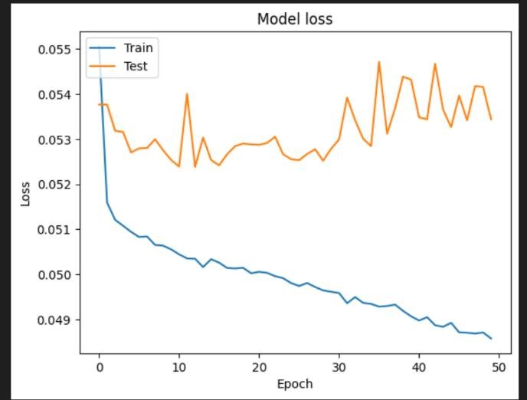

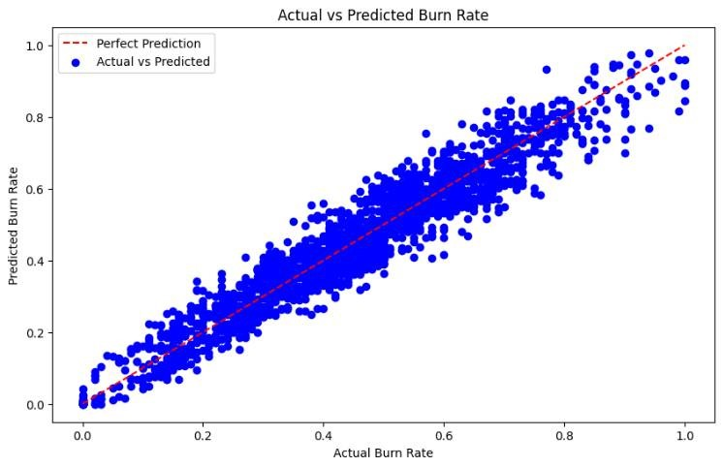

# 3.4 Limitations

The offered code displays a basic regression model that use a neural network to estimate burn rates based on various employee characteristics. However, there are numerous restrictions that can be solved to improve. For starters, the model architecture is simple, which may limit its ability to capture complicated patterns. Incorporating deeper layers or more complicated architectures may improve performance. Furthermore, the dataset preparation is simplistic, neglecting potential feature engineering opportunities or managing categorical variables more efficiently. Furthermore, there has been little research into hyperparameters or regularisation techniques that could help prevent overfitting. Finally, judging model performance exclusively on mean squared error risked overlooking nuances. Using other measures such as MAE or RMSE can provide a more complete picture of model performance.

# 3.5 Individual Contribution by members

## 1. Hardik Kankane 21BCE10413

In the collaborative project "Employee Wellbeing Monitoring and Assurance Using Advanced Analytics", my role in fine-tuning the models and creating synthetic datasets became crucial. I carefully parameterized the training and validation models, ensuring their effectiveness. Diving into the human side, I simulated real-world scenarios in our datasets, managing changing relationships and incorporating just the right amount of complexity. This experience not only sharpened my technical skills, but also instilled a deep appreciation for the human nuances of employee wellness through advanced analytics.

## Paras Verma 21BCE10294

In the collaborative project "Employee Wellbeing Monitoring and Assurance Using Advanced Analytics," In collaboration with my Team mate Tanishka, I conducted thorough research into machine learning models and their accuracies, ultimately opting to implement neural networks. Tanishka's expertise significantly influenced our decision, leading to successful model optimization and remarkable results. Our teamwork fostered dynamic idea exchange and problemsolving, highlighting the effectiveness of collaboration in achieving project objectives.

## Tanishka Mishra 21BCE10249

In the collaborative project "Employee Wellbeing Monitoring and Assurance Using Advanced Analytics", my role was to look after the suitable ML model through which we are going to implement the prediction. The dataset undergoes several preprocessing procedures, including the conversion of the 'Date of Joining' column into individual year, month, week, day, and day of the week features. This helps the programme to identify probable trends in employee tenure. The neural network model architecture consists of three densely linked layers with dropout regularisation to prevent overfitting. I tried to train this model with the Adam optimizer and the mean squared error loss function. I used training and validation loss curves to evaluate model performance, and predictions are compared to actual burn rates using scatter plots, providing insights into the model's predictive skills and potential areas for development.

## 4. Akash Parmar 21BCE11583

My key contribution to the collaborative endeavour dubbed "Employee Wellbeing Monitoring and Assurance Using Advanced Analytics" focused on fine-tuning models and creating synthetic datasets. I meticulously tuned the training and validation models to achieve peak performance. I delved into the human dimension by simulating actual real-world scenarios within our datasets, expertly managing evolving relationships and introducing the proper level of complexity. This immersion training not only sharpened my technical skills, but also gave me a thorough understanding of the nuances of employee wellbeing via the lens of sophisticated analytics.

## 5. Apoorva Gupta21BCE10650

In the collaborative project "Employee Wellbeing Monitoring and Assurance Using Advanced

Analytics," I played a pivotal role in testing numerous algorithms on a sizable dataset provided by Hardik. This involved rigorous testing and analysis, ensuring the efficiency and effectiveness of the chosen algorithms. My focus on frontend development added a layer of user-centric perspective, contributing to the overall success of the project. This experience not only enhanced my technical skills but also highlighted the importance of bridging technical excellence with usercentric design in real-world applications.

## 6. Anondita Dutta 21BCE10537

In the project 'Monitoring and Safeguarding Employee Wellbeing through Advanced Analytics,' I played a pivotal role in exploring various machine learning models. Alongside the chosen model, I researched and evaluated alternative approaches, contributing to the project's comprehensive analysis and decision-making process. My contributions were aimed at ensuring our project not only adopted a robust model for immediate needs but also considered adaptability and scalability for future enhancements.

# 3. CONCLUSION

This code sample uses a neural network regression model to forecast employee burn rates based on a variety of factors. The dataset is preprocessed to remove missing values, transform categorical variables to dummy variables, and extract date features from the 'Date of Joining' column.Following preprocessing, the data is divided into training and testing sets and standardised to ensure consistency across characteristics. The neural network model architecture is made up of three dense layers with dropout regularisation to prevent overfitting.During training, the model uses the Adam optimizer to optimise the mean squared error loss function. The training history is recorded to track the model's convergence.

Following training, the model is evaluated on a test set to determine its performance. The loss metric is calculated and displayed to evaluate the model's accuracy. A scatter map compares the projected and actual burn rates, providing insight into the model's prediction capability.

Overall, the code use a regression model to forecast staff burn rates, utilising neural networks and appropriate preprocessing approaches. It evaluates the model's performance using evaluation metrics and visualisations and serves as a platform for future research and refinement, if necessary.

**4. References:**

1. J. H. Beck, "The effects of the number of roles, the time spent in different roles, and selected demographic variables on burnout and job satisfaction among Iowa Lutheran clergy," Unpublished doctoral dissertation, University of Iowa, Iowa City, 1997. [DOI: N/A]
2. K. Belicki and R. Woolcott, "Employee and patient designed study of burnout and job satisfaction in a chronic care hospital," Employee Assistance Quarterly, vol. 12, no. 1, pp. 37-45, 1996. [DOI: 10.1300/J022v12n01_04]
3. B. Boyd and N. I. Schneider, "Perceptions of the work environment and burnout in Canadian child care providers," Journal of Research in Childhood Education, vol. 11, no. 2, pp. 171-180, 1997. [DOI: 10.1080/02568549709594754]
4. M. S. Bradley, "Affective responses of health-care providers to self-mutilating adolescent behaviors," Unpublished doctoral dissertation, University of Northern Colorado, Greeley, 1994.
5. E. W. Brewer and L. F. Clippard, "Burnout and job satisfaction among student support services personnel," Human Resource Development Quarterly, vol. 13, pp. 169-186, 2002. [DOI: 10.1002/hrdq.3920130205]
6. E. W. Brewer and J. McMahan, "Using meta-analysis as a research tool in making administrative decisions," Unpublished manuscript, University of Tennessee, Knoxville, 2002.
7. P. R. Brown, "Administrative stress and burnout among Seventh-Day Adventist school administrators in the United States," Unpublished doctoral dissertation, La Sierra University, Riverside, CA, 1996.
8. R. J. Burke and E. Greenglass, "A longitudinal study of psychological burnout in teachers," Human Relations, vol. 48, pp. 187-202, 1995. [DOI: 10.1177/001872679504800204]
9. R. J. Burke and A. M. Richardsen, "Stress, burnout, and health," in Stress, Medicine, and Health, C. L. Cooper, Ed. Boca Raton, FL: CRC Press, 1996, pp. 101-117. [DOI: 10.1201/9780429280046-5]
10. W. H. Cheuk, K. S. Wong, and S. Rosen, "The effects of spurning and social support on teacher burnout," Journal of Social Behavior and Personality, vol. 9, pp. 657-664, 1994.Cordes, C. L., & Dougherty, T. W. (1993). A review and an integration of research on job burnout.Academy of Management Review, 18, 621-656.
11. L. Curci, "Burnout in nurses: The effects of specific coping mechanisms," Unpublished doctoral dissertation, California School of Professional Psychology, San Francisco, CA, 1995. DOI: Not applicable.
12. R. Dekel and E. Peled, "Staff burnout in Israeli battered women’s shelters," Journal of Social Service Research, vol. 26, no. 3, pp. 65-76, 2000. DOI: 10.1300/J079v26n03_05
13. G. Dell’Erba, P. Venturi, F. Rizzo, S. Porcu’, and P. Pancheri, "Burnout and health status in Italian air traffic controllers," Aviation, Space, and Environmental Medicine, vol. 65, pp. 315-322, 1994. DOI: 10.3357/ASEM.3748.1994
14. I. L. Densten, "Re-thinking burnout," Journal of Organizational Behavior, vol. 22, pp. 833-847, 2001. DOI: 10.1002/job.108
15. L. C. Dietzel, "Age, consumer difficult behavior, perceived understaffing, workplace social support, and job satisfaction as predictors of emotional exhaustion among psychosocial rehabilitation staff," Unpublished doctoral dissertation, University of Maryland, College Park, 1995. DOI: Not applicable.
16. J. F. Dillon and G. R. Tanner, "Dimensions of career burnout among educators," Journal and Mass Communication Educator, vol. 50, no. 2, pp. 4-13, 1995. DOI: 10.1080/00224065.1995.11979702
17. B. Drake and G. N. Yadama, "A structural equation model of burnout and job exit among Child Protective Service workers," Social Work Research, vol. 20, pp. 179-187, 1996. DOI: 10.1093/swr/20.3.179
18. A. Duquette, S. Kérouac, B. K. Sandhu, and L. Beaudet, "Factors related to nursing burnout: A review of empirical knowledge," Issues in Mental Health Nursing, vol. 15, pp. 337-358, 1994. DOI: 10.3109/01612849409006975
19. E. S. Finch and S. R. Krantz, "Low burnout in a high-stress setting: A study of staff adaptation at Fountain House," Psychosocial Rehabilitation Journal, vol. 14, no. 3, pp. 15-26, 1991. DOI: 10.1037/h0095278
20. M. H. Foreman, "The relationship between burnout and depression subtypes among clergy," Unpublished doctoral dissertation, United States International University, San Diego, CA, 1996. DOI: Not applicable.Gabris, G., & Ihrke, D. M. (1996). Burnout in a large federal agency: Phase model implications for how employees perceive leadership credibility. Public Administration Quarterly, 20, 220-249.
21. G. V. Glass, B. McGaw, and M. L. Smith, "Meta-analysis in social research," Beverly Hills, CA: Sage, 1981. DOI: Not applicable.
22. L. Pedrabissi, J. P. Rolland, and M. Santinello, "Stress and burnout among teachers in Italy and France," Journal of Psychology, vol. 127, pp. 529-535, 1993. DOI: 10.1080/00223980.1993.9914877
23. J. E. Poulin and C. A. Walter, "Burnout in gerontological social work," Social Work, vol. 38, pp. 305-310, 1993. DOI: 10.1093/sw/38.3.305
24. D. W. Rainey, "Source of stress, burnout and intention to terminate among basketball referees," Journal of Sport Behavior, vol. 22, pp. 578-590, 1999. DOI: 10.1037/a0016395
25. N. J. Razza, "Determinants of direct-care staff turnover in group homes for individuals with mental retardation," Mental Retardation, vol. 31, pp. 284-291, 1993. DOI: 10.1352/0895-8017(1993)031<0284:DODSTT>2.0.CO;2
26. H. D. Reiner and T. S. Hartshorne, "Job burnout and the school psychologist," Psychology in the Schools, vol. 19, pp. 508-512, 1982. DOI: 10.1002/1520-6807(198210)19:4<508::AID-PITS2310190410>3.0.CO;2-5
27. V. Rich and A. R. Rich, "Personality hardiness and burnout in female staff nurses," IMAGE: Journal of Nursing Scholarship, vol. 19, no. 2, pp. 63-66, 1987. DOI: 10.1111/j.1547-5069.1987.tb00044.x
28. G. J. Rittenmyer, "The relationship between early maladaptive schemas and job burnout among public school teachers," Unpublished doctoral dissertation, University of the Pacific, Stockton, CA, 1997. DOI: Not applicable.
29. W. B. Schaufeli and D. Enzmann, "The burnout companion to study and practice: A critical analysis," London: Taylor & Francis, 1998. DOI: Not applicable.
30. N. Schutte, S. Toppinen, R. Kalimo, and W. Schaufeli, "The factorial validity of the Maslach Burnout Inventory–General Survey (MBI-GS) across occupational groups and nations," Journal of Occupational and Organizational Psychology, vol. 73, pp. 53-66, 2000. DOI: 10.1348/096317900166877
31. R. Schwarzer, "Meta-analysis programs," Retrieved October 23, 2001, from http://www.yorku.ca/faculty/academic/schwarze/meta_e.htm. DOI: Not applicable.
32. J. Seltzer and R. E. Numerof, "Supervisory leadership and subordinate burnout," Academy of Management Journal, vol. 31, pp. 439-446, 1988. DOI: 10.5465/256367
33. J. M. Sermon, "The relationship of the dual role assignment to the level of perceived burnout by secondary teachers," Unpublished doctoral dissertation, Florida State University, Tallahassee, 1994. DOI: Not applicable.
34. V. Sethi, T. Barrier, and R. C. King, "An examination of the correlates of burnout in information systems professionals," Information Resources Management Journal, vol. 12, no. 3, pp. 5-13, 1999. DOI: 10.4018/irmj.1999070102
35. A. Sharma, "A study of frontline spite care workers in Louisiana, United States of America," Unpublished doctoral dissertation, Florida State University, Tallahassee, 1996. DOI: Not applicable.
36. J. Singh, J. R. Goolsby, and G. K. Rhoads, "Behavioral and psychological consequences of boundary spanning burnout for customer service representatives," Journal of Marketing Research, vol. 31, pp. 558-569, 1994. DOI: 10.2307/3152190
37. J. L. Skaggs, "Burnout in relationship to counselors’ use of power: Predicting risk with Machiavellianism," Unpublished doctoral dissertation, Idaho State University, Pocatello, 1999. DOI: Not applicable.
38. R. Stanton, M. Howard, A. Iso, and E. Seppo, "Burnout and leisure," Journal of Applied Social Psychology, vol. 28, pp. 1931-1950, 1998. DOI: 10Starnaman, S. M., & Miller, K. I. (1992).A test of a causal model of communication and burnout in the teaching profession. Communication Education, 41(1), 40-53.
39. Tan, D. S. K., & Akhtar, S. (1998). Organizational commitment and experienced burnout: An exploratory study from a Chinese cultural perspective. International Journal of

**APPENDIX**

**RANDOM FOREST MODEL**

1. import pandas as pd
2. from sklearn.model_selection import train_test_split
3. from sklearn.ensemble import RandomForestRegressor
4. from sklearn.metrics import mean_squared_error, r2_score
5. import matplotlib.pyplot as plt
6. # Load data
7. data = pd.read_csv("empdata.csv")
8. # Data preprocessing
9. data = pd.get_dummies(data, columns=['Gender', 'Company Type', 'WFH Setup Available'], prefix=['Gender', 'Company', 'WFH'])
10. data.dropna(inplace=True)
11. X = data.drop(['Employee ID', 'Burn Rate','Date of Joining'], axis=1)
12. y = data['Burn Rate']
13. # Split data into training and testing sets
14. X_train, X_test, y_train, y_test = train_test_split(X, y, test_size=0.1, random_state=42)
15. # Train Random Forest model
16. rf_model = RandomForestRegressor(random_state=42)
17. rf_model.fit(X_train, y_train)
18. # Make predictions
19. y_pred = rf_model.predict(X_test)
20. # Evaluate model
21. mse = mean_squared_error(y_test, y_pred)
22. r2 = r2_score(y_test, y_pred)
23. # Print evaluation metrics
24. print("Mean Squared Error:", mse)
25. print("R^2 Score:", r2)
26. # Plotting the predicted vs actual values
27. plt.figure(figsize=(10, 6))
28. plt.scatter(y_test, y_pred, color='blue', label='Actual vs Predicted')
29. plt.plot([min(y_test), max(y_test)], [min(y_test), max(y_test)], color='red', linestyle='--', label='Perfect Prediction')
30. plt.xlabel('Actual Burn Rate')
31. plt.ylabel('Predicted Burn Rate')
32. plt.title('Actual vs Predicted Burn Rate')
33. plt.legend()
34. plt.show()
35. 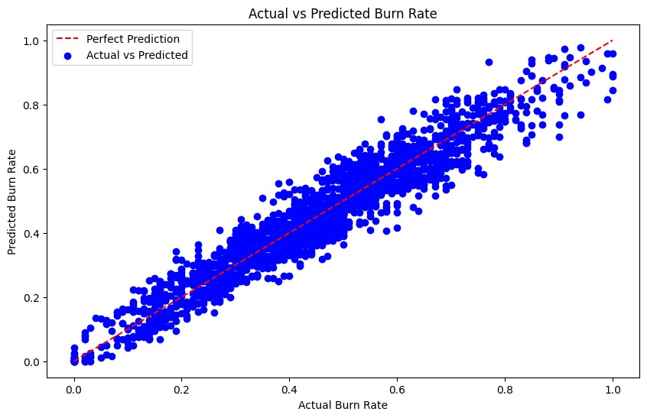

import pandas as pd

import numpy as np

import tensorflow as tf

from sklearn.model_selection import train_test_split

from sklearn.preprocessing import StandardScaler

from tensorflow.keras.models import Sequential

from tensorflow.keras.layers import Dense

from sklearn.metrics import mean_squared_error

import matplotlib.pyplot as plt

# Load the dataset

data = pd.read_csv('generated_data.csv')

data.drop(columns=['Working Since (Date)'], inplace=True)

data_encoded = pd.get_dummies(data, columns=['Gender', 'Work Type', 'Employee Position'])

X = data_encoded.drop(columns=['Burn Rate']).values # Features

y = data_encoded['Burn Rate'].values # Target

X_train, X_test, y_train, y_test = train_test_split(X, y, test_size=0.2, random_state=42)

scaler = StandardScaler()

X_train_scaled = scaler.fit_transform(X_train)

X_test_scaled = scaler.transform(X_test)

# Define the model

model = Sequential()

model.add(Dense(64, input_dim=X_train_scaled.shape[1], activation='relu'))

model.add(Dense(32, activation='relu'))

model.add(Dense(16, activation='relu'))

model.add(Dense(1, activation='linear'))

# Compile the model

model.compile(loss='mean_squared_error', optimizer='adam')

1. **NEURAL NETWORK MODEL**

# Train the model

history = model.fit(X_train_scaled, y_train, validation_data=(X_test_scaled, y_test), epochs=50, batch_size=32)

# Make predictions

y_pred = model.predict(X_test_scaled)

# Calculate Mean Squared Error

mse = mean_squared_error(y_test, y_pred)

print("Mean Squared Error:", mse)

# Plot training & validation loss values

plt.plot(history.history['loss'])

plt.plot(history.history['val_loss'])

plt.title('Model loss')

plt.ylabel('Loss')

plt.xlabel('Epoch')

plt.legend(['Train', 'Test'], loc='upper left')

plt.show()

1. 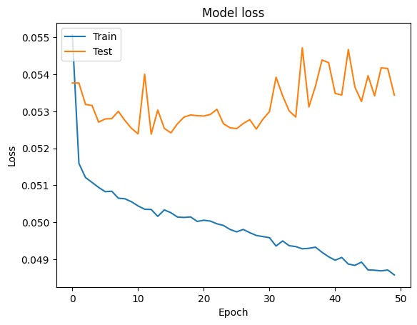

**5. Biodata:**

# 1.AKASH PARMAR

I am Akash Parmar, currently in my third year of pursuing in Computer Science. My academic journey has been marked by a passion for technology and a relentless pursuit of knowledge in the field . With proficiency in a diverse set of skills, I specialize in MERN (MongoDB, Express.js, React.js, Node.js) Full Stack development, where I have gained hands-on experience in building dynamic web applications. Additionally, my expertise extends to Data Structures and Algorithms (DSA), an essential aspect of software development, and I am proficient in C++, a versatile programming language widely used in the industry . As a student deeply invested in the realm of computer science, I am enthusiastic about exploring new opportunities and challenges to further develop my skills and contribute meaningfully to the tech community. Whether it's crafting innovative solutions to real-world problems or collaborating with peers to push the boundaries of technology, I am driven by a desire to make a positive impact through my work.

# 2.HARDIK KANKANE

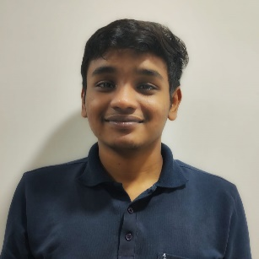Hello, I'm Hardik Kankane, currently pursuing B.Tech in Computer Science. Specializing in Linux application development and Bash scripting, I excel in creating seamless, efficient solutions within the Unix Operating System. My proficiency extends to Django and cloud technologies, allowing me to deliver robust applications. With a keen focus on clean code, I prioritize simplicity and functionality in every project. My commitment to Linux environments ensures a solid foundation for innovation, emphasizing a seamless development process. Excited to contribute to cutting-edge projects, I bring a comprehensive skill set that harmonizes technical depth with practical application, striving for excellence in the dynamic field of technology.

## 3. PARAS VERMA

I am Paras Verma, currently embarking on a rewarding academic journey in pursuit of a Bachelor of Technology degree with a specialization in front-end development. Furthermore, I am deeply invested in the captivating field of UI/UX design. My professional aspirations lie in the meticulous construction of user interfaces that not only possess a visually compelling aesthetic but also prioritize the creation of intuitive and seamless user experiences. Beyond the realm of visual appeal, my skillset extends to the powerful programming languages of C++ and Python . I possess a strong proficiency in both, allowing me to meticulously dissect complex technological problems into manageable components.

# 4.TANISHKA MISHRA

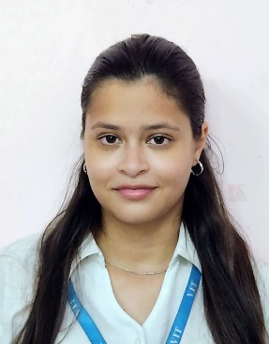

I'm Tanishka Mishra, currently pursuing my B.Tech in Computer Science and Engineering. My love for coding runs deep, especially when it comes to delving into the complexities of the MERN stack and ML.Moreover, I am committed to lifelong learning and skill enhancement, always on the lookout for opportunities to broaden my expertise across different sources and platforms. I am very fond of implementing these techniques in the real world. Apart from these, I have a different side of me which loves to travel and hang out at different places with my friends and play Video Games.

# 5.APOORVA GUPTA

I am Apoorva Gupta, currently embarking on a rewarding academic journey in pursuit of a Bachelor of Technology degree with a specialization in front-end development. Furthermore, I am deeply invested in the captivating field of UI/UX design. My professional aspirations lie in the meticulous construction of user interfaces that not only possess a visually compelling aesthetic but also prioritize the creation of intuitive and seamless user experiences. Beyond the realm of visual appeal, my skillset extends to the powerful programming languages of Python and MySQL. I possess a strong proficiency in both, allowing me to meticulously dissect complex technological problems into manageable components.

# 6.ANONDITA DUTTA

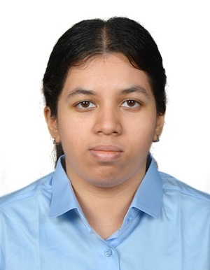I am Anondita Datta, currently pursuing a Bachelor of Technology degree in Computer Science and Engineering. My academic interests are deeply rooted in the fields of Data Analytics and Cybersecurity. I love the intricate number dance and the careful challenge of keeping data safe. These areas pique my interest and inspire my professional aspirations, because I am determined to strive for the research rigor and methodological insights needed to drive critical data security practices in data science and in cybersecurity has grown